Week 2 Session 8 Functional Programming using reduce()
- Maximum Subarray
class Solution {
public int maxSubArray(int[] nums) {

int currentSum = nums[0];
int maxSum = nums[0];

for (int i = 1; i < nums.length; i++) {

currentSum = Math.max(nums[i], currentSum + nums[i]);

maxSum = Math.max(maxSum, currentSum);
}

return maxSum;
}
}
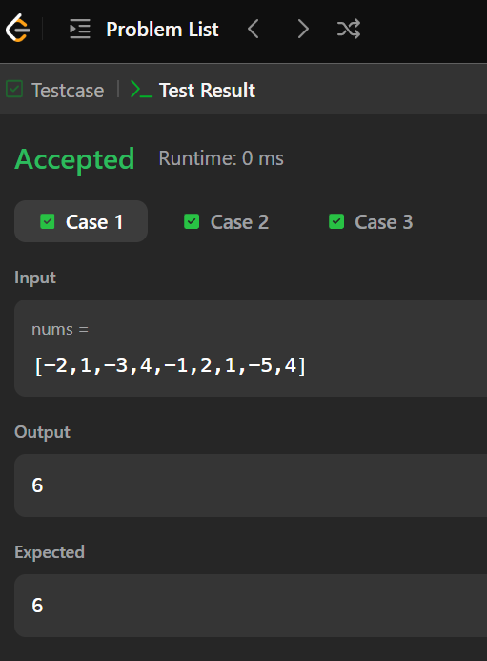
- 2. Find the Highest Altitude
class Solution {
public int largestAltitude(int[] gain) {

int altitude = 0;
int highest = 0;

for (int i = 0; i < gain.length; i++) {

altitude = altitude + gain[i];

highest = Math.max(highest, altitude);
}

return highest;
}
}
